
2nd Toowoomba Scout’s Newsletter
23rd May 2008

Scouts 2nd Toowoomba Committee Meeting
May 16th, 2008

Present:

Sharron Currie, Jeni Bonell, Kelly Addison, Darren McDonald, Priscilla Lanzafame, Doug Maddocks, Jodie Maddocks, Tracey Ferguson, Corby Orford, Iris Baird, Bob Baird, Sze-Ming Wall, Andrew Scotney, Ken Windley, Darren McDonald
- Meeting opening – Meeting commenced at 7.11pm.
- Apologies – Kim Brincat, Kim Schramm, Craig Schramm, Jodie Maddocks,
- Minutes of Previous Meeting – minutes read and accepted as true and correct. Moved by Iris Baird, seconded by Doug Maddocks
- Business Arising –

- Banner: - being done by Orford Sign Shop. Should be available by the next meeting. The price was better than the original quote
- Nighthawk – Meeting occurred last night. 2nd Toowoomba committed to continue to manage the Milo Base. Darren McDonald has put together a list of tasks to be undertaken. Interested helpers should give their names to Darren McDonald. The jobs list will be sent out once completed.
  - 400lts of Milk is to organised by Orford Refrigeration.
  - Need Milo donated approximately $12 per tin.
  - Discussion over the name of the base, decided to name the base after the largest sponsor eg “gourmet Butcher Base”.
  - 4 toilets have been organised.
  - 1200 chocolates have been donated.
  - Peter Keeton was investigating biscuits.
  - Corby Orford organising a fridge through Joe Ramia.
- Pest Control – the external areas have been done with internal to be arranged. Kelly Addison is managing. Keys to be organised
- Key Register – keys continue to change, no real control at this stage. The keys to the shed have been lost. Developing the key register – Kelly prepared to develop the spreadsheet. Russell Siebuhr has good knowledge of how key registers work. Question raised re getting buildings keyed alike, this presents challenges when trying to secure goods with multiple key holders.

- Treasurers Report – Kelly Addison
- $8169.26 in general account
- $2145 for concrete to be paid
- $399 tent has been paid. This was purchased at half price.
- Lions dinner – 324.50 has been paid
- $473 for life jacket has been paid
- Term deposits expiring in June and July for $10000 + $10000
- Discussion regarding rolling over the fixed deposits, agreement to roll over the term deposit as money not immediately required.
- Signatories have been replaced on the relevant accounts
- $1107.18 bill received but was incorrect, now $862.49 for Leadership fees. A 590 discount was given – an incentive program
- The Bonell family were overcharged by Scouts Qld. Agreement to refund $45.13. Moved J. Bonell, seconded Andrew Scotney
- In 2002, the committee agreed not to pay $1000 of the insurance charge, this is slowly dwindling
- The membership bill for about
- All Executive committee members must have a Blue Card. As the Blue Cards are issued free of charge, there should be records of holders should Scouts Qld do a spot check
- When families join, please sign all siblings up with the same family codes
- Children coming from other Troops should have the correct paperwork. Kelley Addison can set this up in Quickbooks. We need to check that every kid is fully paid up as a 2nd Toowoomba member
- Training was undertaken for 2 Leaders, a $115 invoice will arrive shortly
- The property return is still to be done. When the invoice is received ($3500) it is recommended that it isn’t paid until November.
- Insurance Explanation
  - There is public liability rolled up into other insurance costs
  - There is a $500 excess on most claims
  - There is no insurance on contents as they are easily replaceable
  - Only the buildings are insured
- Banking from the Groups is delayed, recommended that this is handed in weekly
- Incoming Correspondence -
- Letter from Anzac Day committee thanking us for participation
- Outgoing Correspondence –
- Nil
- Leaders Report
- Host family in June and September from France and Italy. Interested families please let us know
- Leaders from around Queensland have a function coming up soon covering things like mock emergency training. It is a social Saturday night but a busy weekend
- Venturers need a flag pole, so they can run their own meetings. One is available at the cub hut
- Shirts, Orford Sign Shop sourcing shirts. Having difficulties sourcing a shirt to suit from children to adults
- All sections doing well
- Cubs want a power point and RCD and to have the hut painted
- Sections should be providing reports to Kirsty Baird allowing her to complete the report.
- Fundraising Report – Iris Baird
- Cent sale went well. Made $620 after paying for expenses
- Chocolate drive doing well. Money needed by 23th May 2008.
- Some equipment purchased some years back that was never used will become our next raffle. $1 per ticket once organised
- QBSI rules state that the Venturers must be earned. Youth members cannot sell raffle tickets. They can sell chocolates as they are an earned activity. Anything seen as soliciting such as selling raffles can not be done by the children. The committee will comply with these rules
- Events coming up are
  - July 26th – Christmas in July at the Bowls Club in Victoria St. $150 to hire the hall. The format is a sit down, two course meal. MC needed for the night. Need a sponsor for the multi-draw raffle, between $300 and $400
  - September 19th Freddo Chocolate Drive
  - September 20th Carnival seating, at least 15 people are needed for this event
  - Trivia Night – To be advised
  - Art Union – to be advised
- General Business
- The website is updated by Russell and Kathy Siebuhr. If parents want other information included, they are welcome but noone is actually responsible for accessing the web for non Groups information.
- Darren McDonald tabled an email from the Scouting Marketing Department asking if Scouts are interested in attending Big Brother. Agreement that an official complaint should be put in re Scouts encouraging association with Big Brother
- Bob Baird asked if a working bee could be arranged to clean out the gutters on huts. Possibly to hold this early next term. To be placed on the agenda for next meeting.

Meeting closed at 8.25 hrs
The next meeting is June 13th 2008

From the Group Leader
- Host family in June and September from France and Italy. Interested families please let us know
- Leaders from around Queensland have a function coming up soon covering things like mock emergency training. It is a social Saturday night but a busy weekend
- Shirts, Orford Sign Shop sourcing shirts. Having difficulties sourcing a shirt to suit from children to adults
- All sections doing well
- Sections should be providing reports to Kirsty Baird allowing her to complete the report.
Fundraising News
- Cent sale went well. Made $620 after paying for expenses
- Chocolate drive doing well. Money needed by 23th May 2008.
- Some equipment purchased some years back that was never used will become our next raffle. $1 per ticket once organised
- QBSI rules state that the Venturers must be earned. Youth members cannot sell raffle tickets. They can sell chocolates as they are an earned activity. Anything seen as soliciting such as selling raffles can not be done by the children. The committee will comply with these rules
- Events coming up are
  - July 26th – Christmas in July at the Bowls Club in Victoria St. $150 to hire the hall. The format is a sit down, two course meal. MC needed for the night. Need a sponsor for the multi-draw raffle, between $300 and $400
  - September 19th Freddo Chocolate Drive
  - September 20th Carnival seating, at least 15 people are needed for this event
  - Trivia Night – To be advised
  - Art Union – to be advised

Joey News
Recently the Mob has in ceremonies that were held on ANZAC Day, were visited by some native animals for their Environmental Challenge Badge and have earned their Harmony Badge. 3 Joey’s recently visited the Darling Downs Zoo and we received donations including a CD player and a kettle.
The Joey’s will be having a Miniature Steam Train Day on the 27th July. For any information on more upcoming events, please contact your Leader.

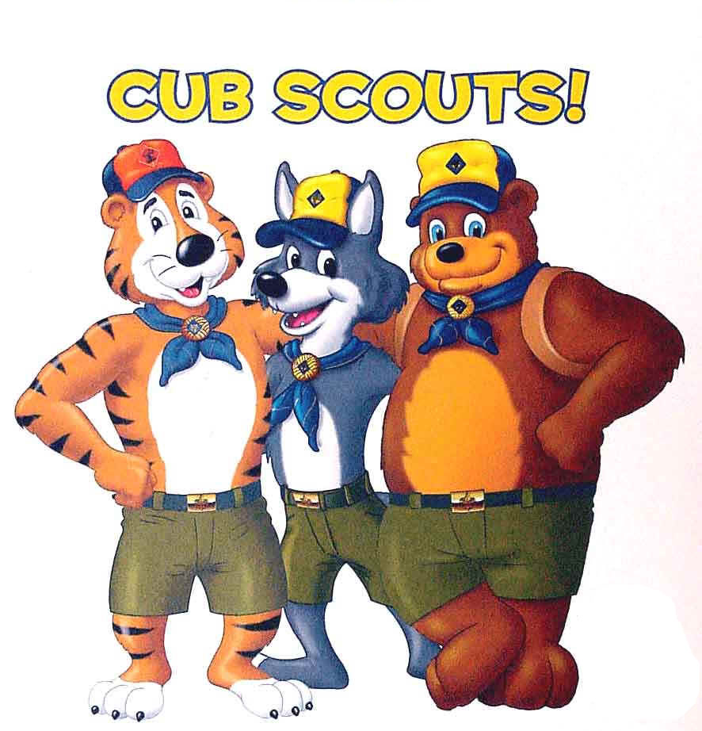
Cub News
Currently, Robert Cheek, a Cub parent, is taking the first steps in becoming a Cub Scout Leader. Please get to know him. We are also still looking for a Female Leader to help as well. We have lots of badgework planned into our activites for this month which will hopefully involve boomerangs being completed soon. The theme for the month of May is Waterwise, please contact your leader if you have any questions. Upcoming Events:
- 31st May – Cycling Day in Brisbane (QLD Branch Activity)
- 28th June – Crows Nest Sleepover and hike
- 29th July – Bunya Mountains Winter Camp

Scout News
3 teams recently competed in Swamp Rat and did very well. Out of 24 teams we managed to take 3rd, 4th and 5th, being a great achievement as this is the first time we have competed in this regional activity. Over the long weekend 5 of our Scouts took part in a 3 day, Adventurer (Green) Level Hike on their own.
Upcoming Events:
- 23-25th May – Standards Camp, Cumorah
- 1st June – Milne Bay Military Museum Visit
- 21st/22nd June – Proposed Troop Camp


Venturer News
ANZAC Day was attended by all 2nd Toowoomba Venturers where they participated in the Drayton Parade and assisted in the Distribution of water at the main parade. Unfortunately, the Expeditions Hike has been cancelled due to unforseen circumstances.
Monday 5th May saw 5 Venturers at the Den preparing for Standards camp on the 18th & 19th May where all the equipment was made ready to pack on the Friday. They went down with the theme of Cowboys and returned with the Try Hard Award that was presented because of their efforts they put into making their theme possible throughout some of the weekend.
Upcoming Events:
- 1st June – Milne Bay Military Museum Visit

Rover News
The Rovers recently attended many of the ANZAC Day Services that commenced at Dawn and may have ended at a Queen Scout Presentation at 3pm. We also assisted the leaders at Standards Camp by providing a Campfire to aid the Venturers in competing for the Campfire Trophy as well as whenever the Leaders may have needed our assistance.
Upcoming events are to be discussed with Dave Edmonston to arrange linking and going-up ceremonies for some of Venturer Unit.

2nd Toowoomba Major Sponsors include


Gardentown & Bridge St

Newsletter created by: Kirsty Baird, Rover Crew

